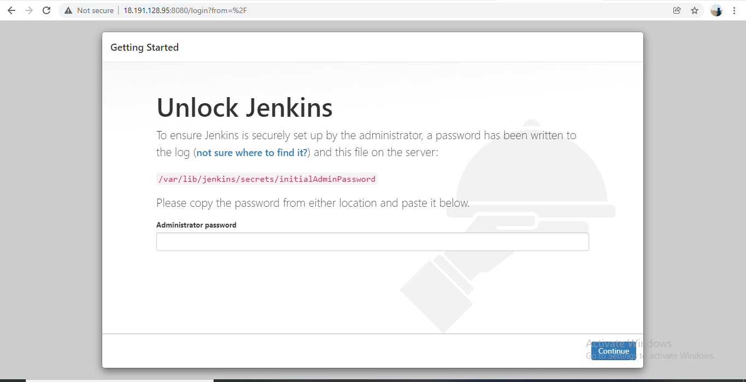

Once you received the page plz go through the above listed command

/var/lib/jenkins/secrets/initialAdminPassword

You will be find the secret code and copy & paste init.

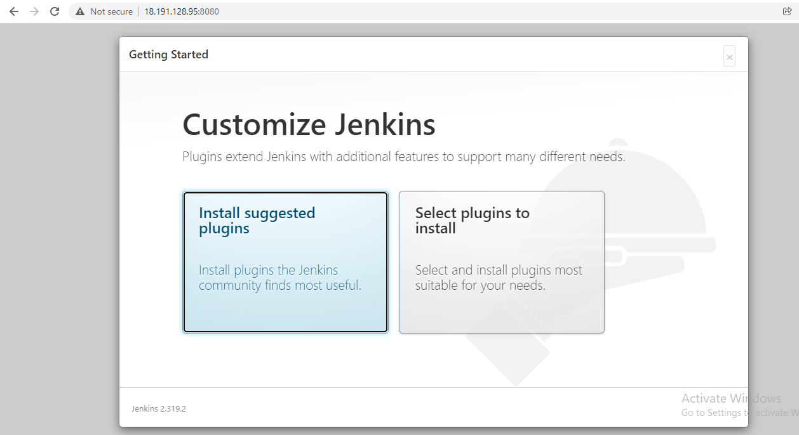

Select the suggested plugins and provide the credentials for it to use it

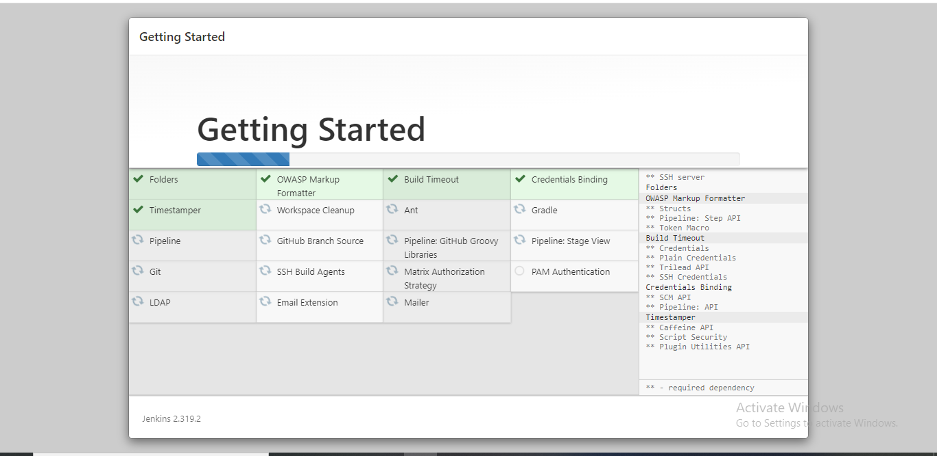

Once you click on the suggested plugins it install the plugins as shown in above.

Click on Next to get the below page and provide the credentials which you required to access it .

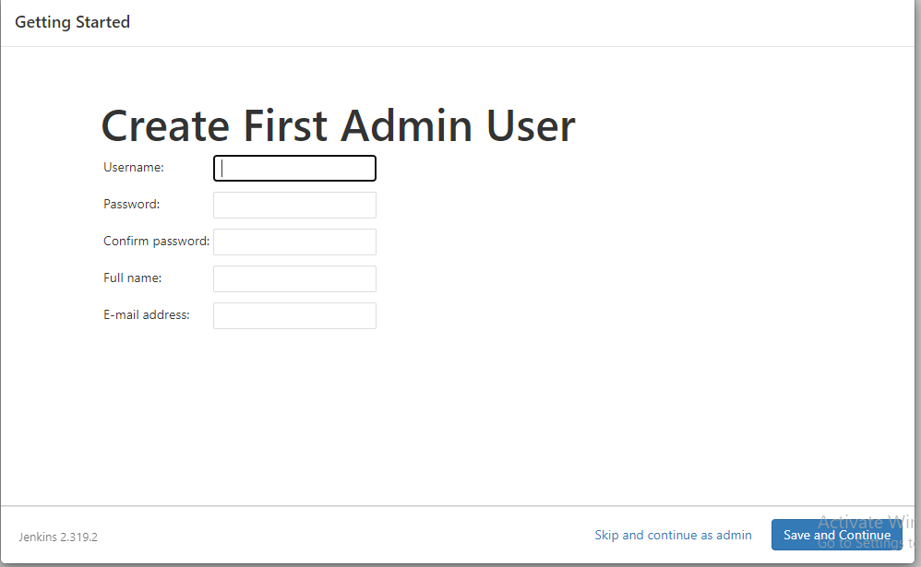

Once everything is finished you will getting the below page showing the Jenkins pages

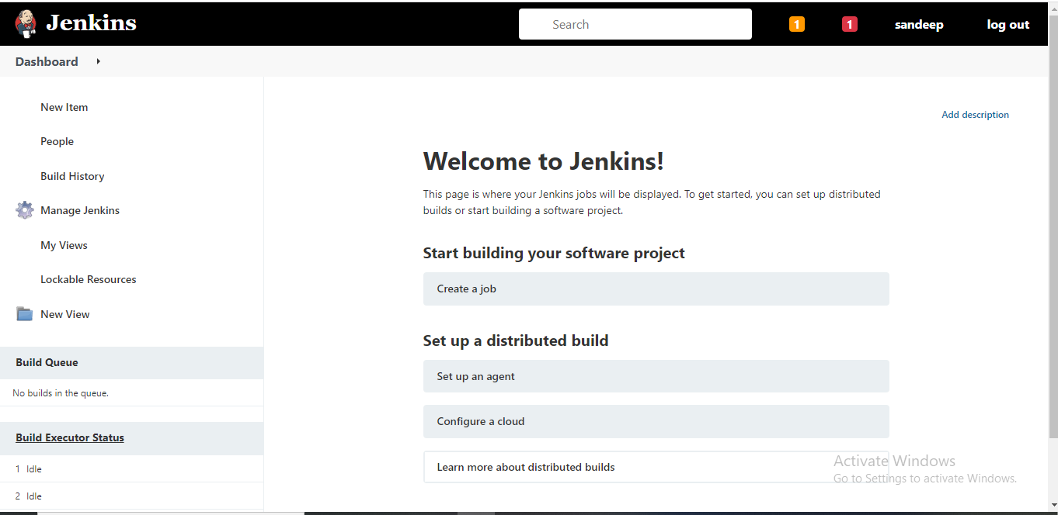

**Job Creation in Jenkins**

Select the new item in the Jenkins dashboard >Give the name of project >select the free style of project.

Now select the source management code and select the Git option

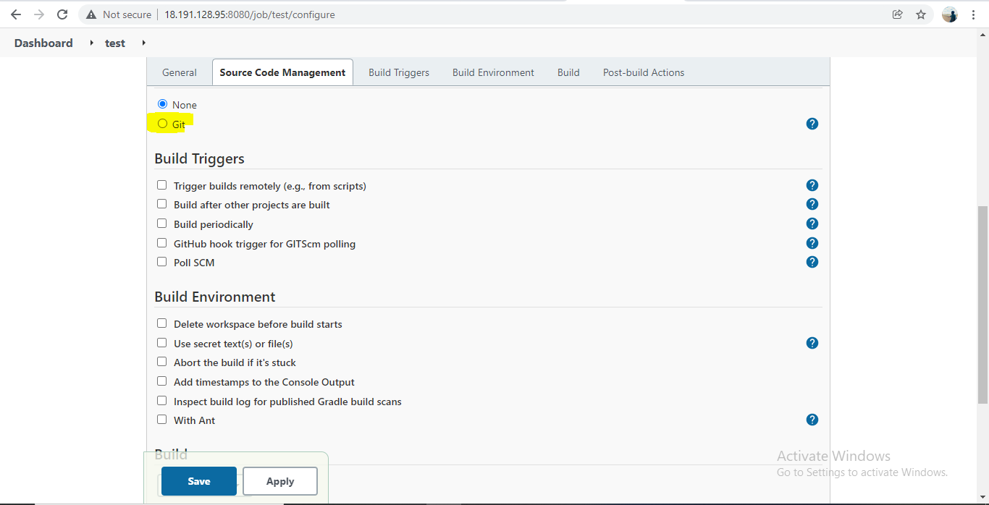

Enter the GitHub url,where your code is available

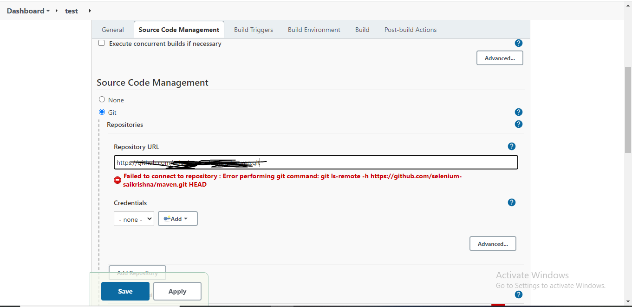

Now apply and save the git,click apply and save.

Then you will be getting below page

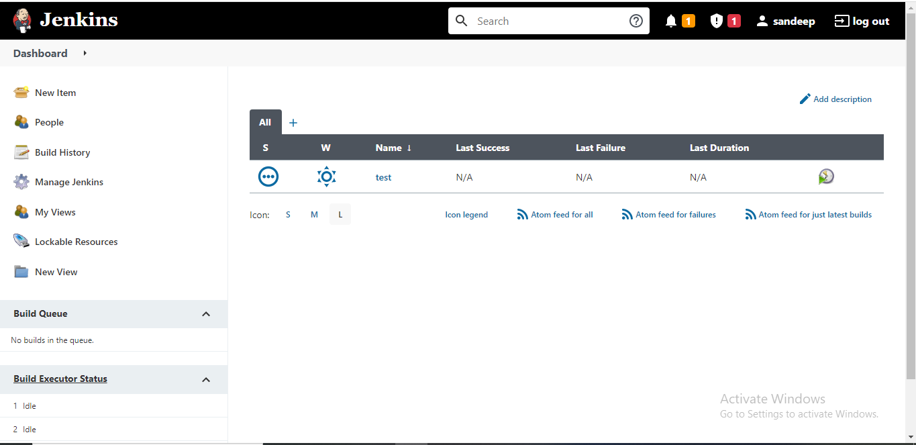

Now build the job on the above snap

Then job will be executed and check whether success or failed status

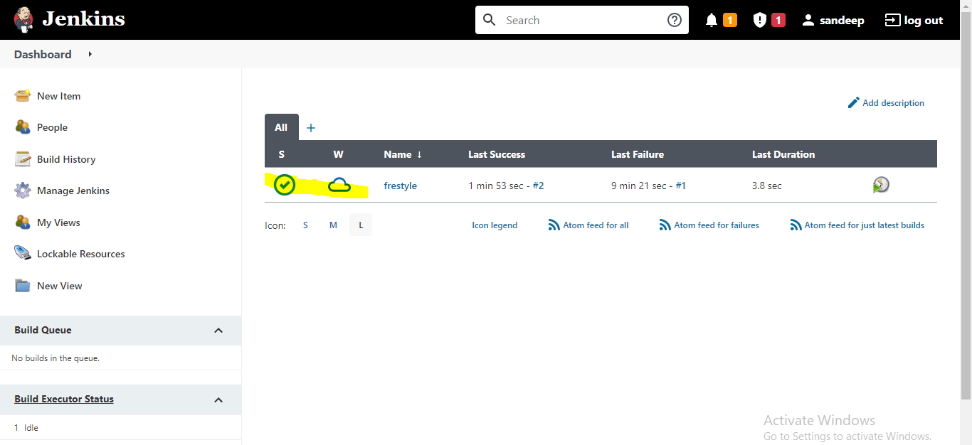

**Job Scheduling /Scheduling cron jobs In Jenkins**

Now go to the dashboard of build and select the configure.

Once it done just select the build triggers option in it as shown

Click on build periodically or poll SCM

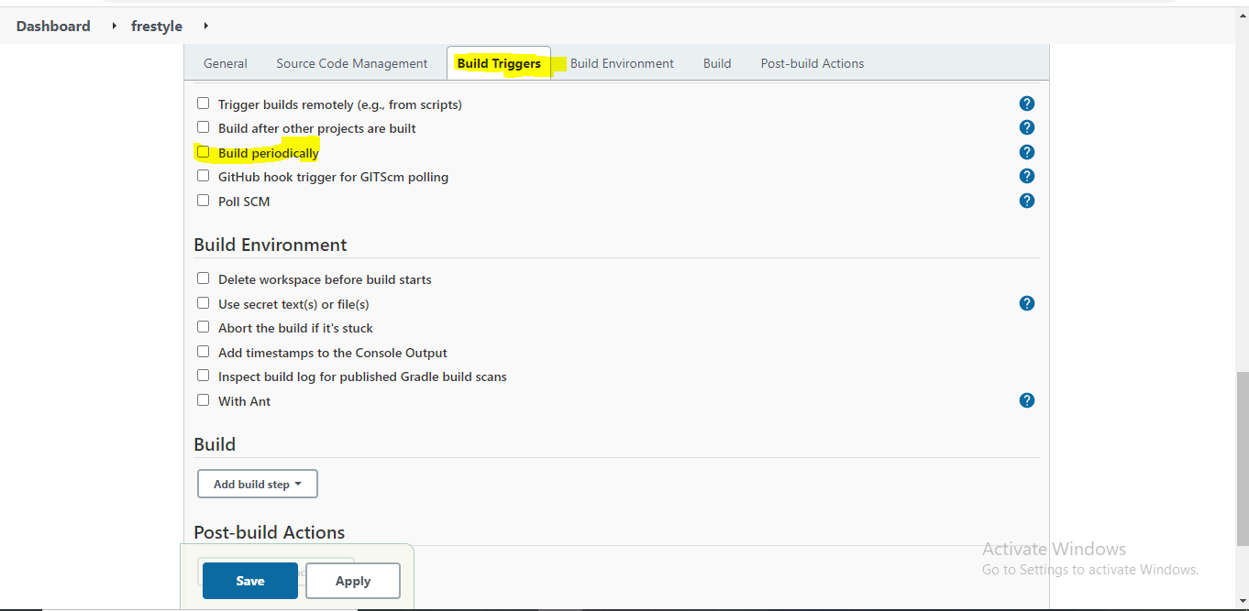

Now am scheduling my build to run every 15min as shown in snap click apply and save

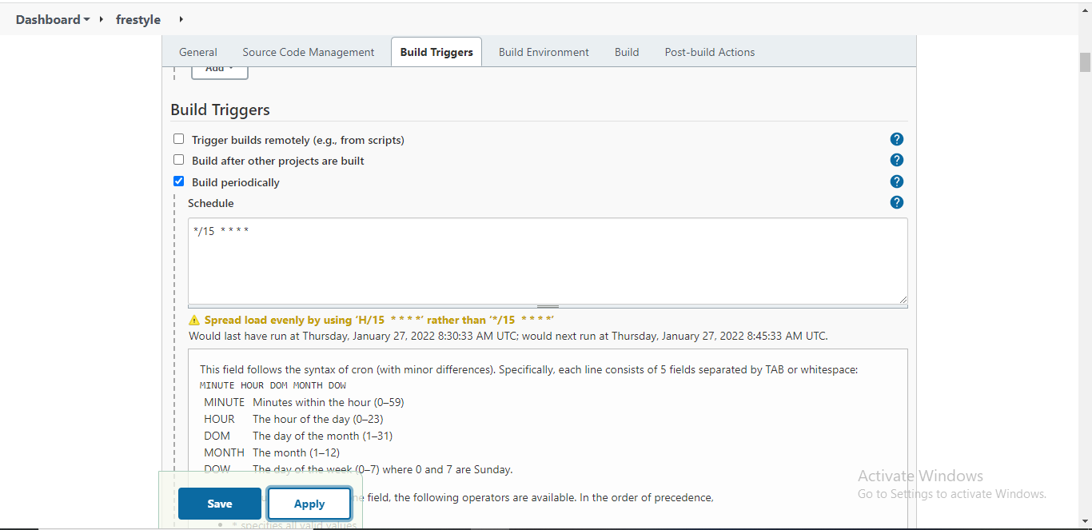

Creating the slaves

Slaves will be distributes the build job on different systems/servers to run the build 2 jobs at a time

Basic steps of Master/slave

Creating the slaves, we required the couple of instances to configure the Master, slave machines.

We need to configure the machines with same configuration on all the machines and need to establish the password less ssh to easily access to slaves from master machine. Then only Master machine can access slave machine and the build will run without errors

Open the dashboard of jenkins >click on manage jenkins>click on manage nodes>enter new node & enter the name>select the permanent agent

Once you go to above chain you will be getting below page and fill the details of your slave machine

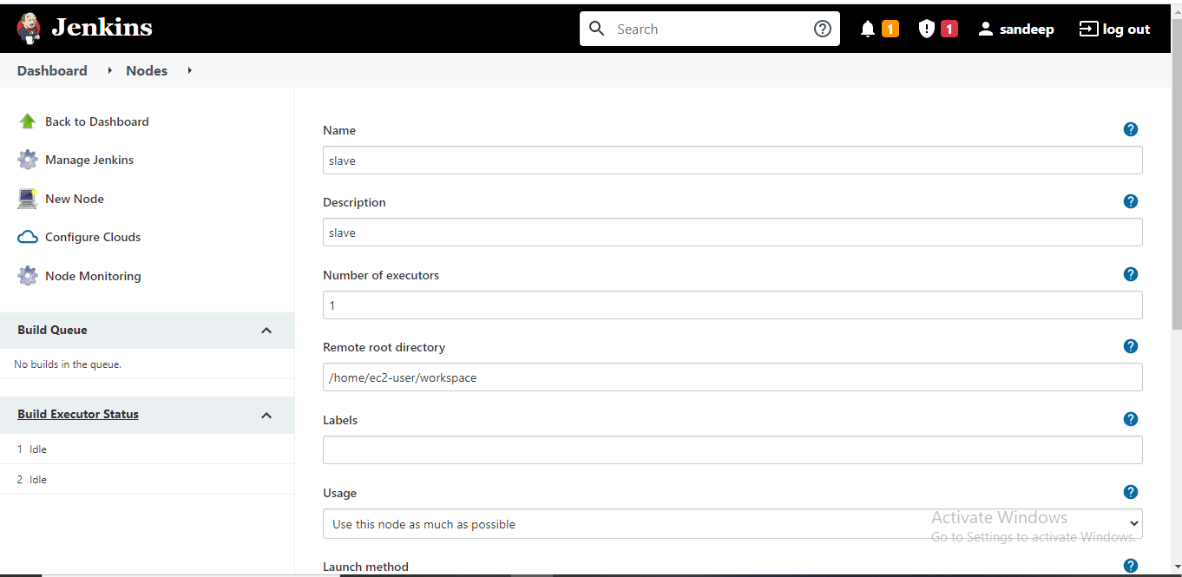

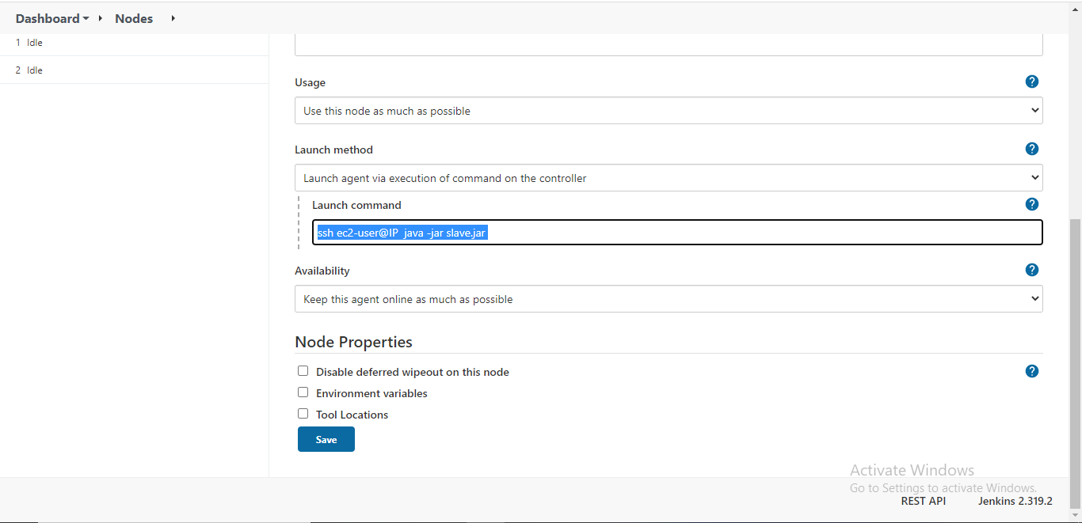

Once you enter your slave details over here,click on save

**Now go the dashboard of jenkins >select the job you require > go to configure section>click on general section >click on the restrict where this project can be run & enter the slave label**

Click on apply and save

**Mange plugins/Installing plugins**

Plugins are **the primary means of enhancing the functionality of a Jenkins environment to suit organization- or user-specific needs**. There are over a thousand different plugins which can be installed on a Jenkins controller and to integrate various build tools, cloud providers, analysis tools, and much more

Go to the Jenkins Dashboard >select the Manage jenkins>Manage Plugins

Go to available section and search for the plugin you required >Install the plugin in that list with restart of jenkins and without restart of jenkins

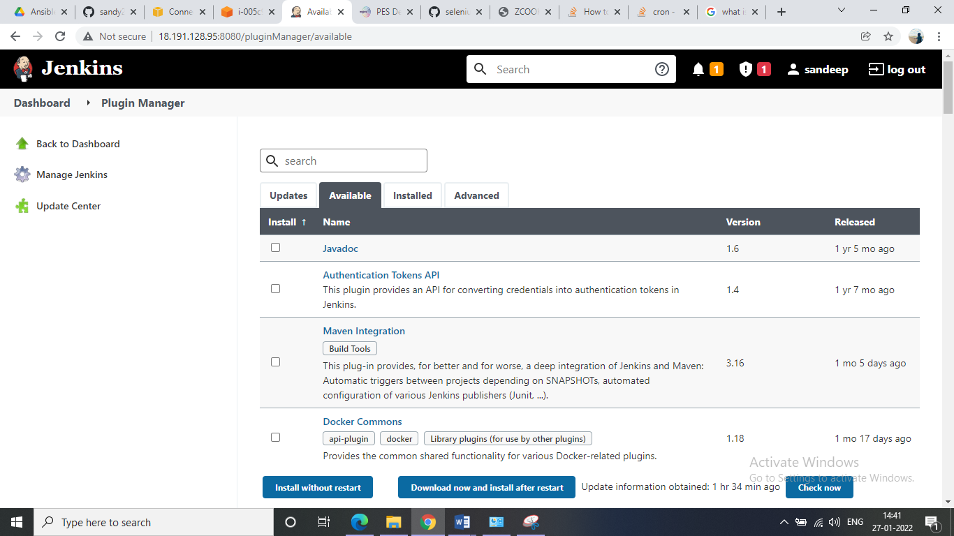

Continuous build

Go Jenkins Dashboard> Go to job dashboard>configure>Add build setup >click on the invoke maven targets.

In the goal section type as package >click on apply and save

Now go to dashboard and start the build the downloaded code will converts into artifacts

Continuous Deployment:

Once the code is build and converted to artifact we need to deploy it in the testing servers to test the artifact. For deployment we need to install one plugin deploy to container from manage plugins

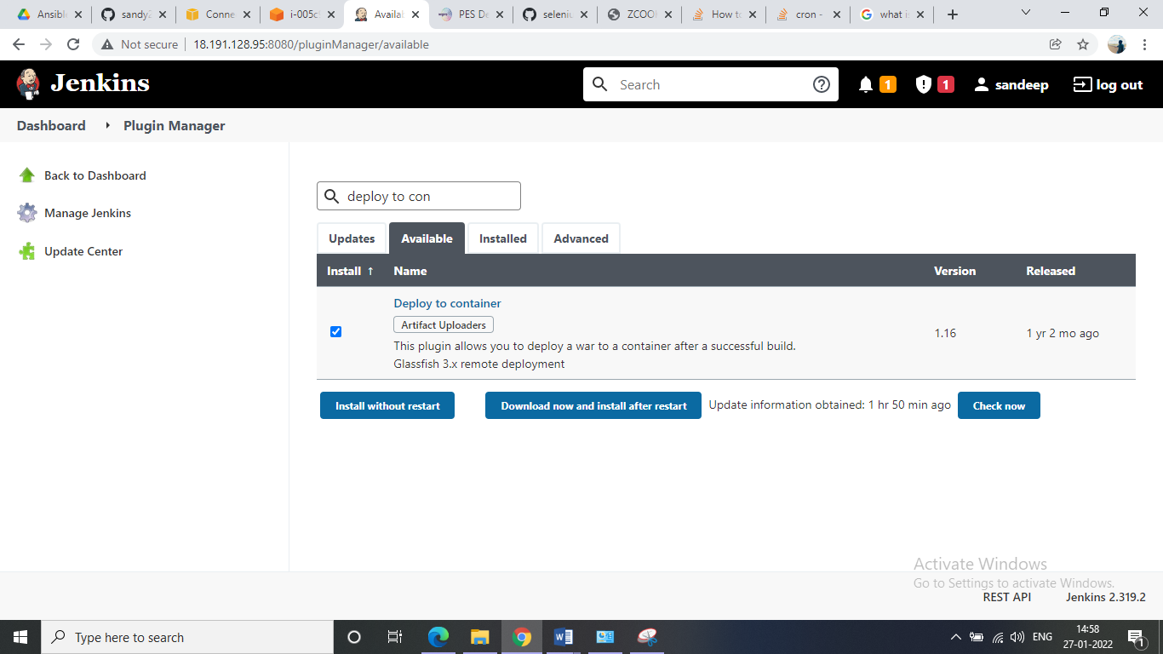

Once the plugin is installed move to the job dashboard>configure>post build actions>select deploy war/ear to a container

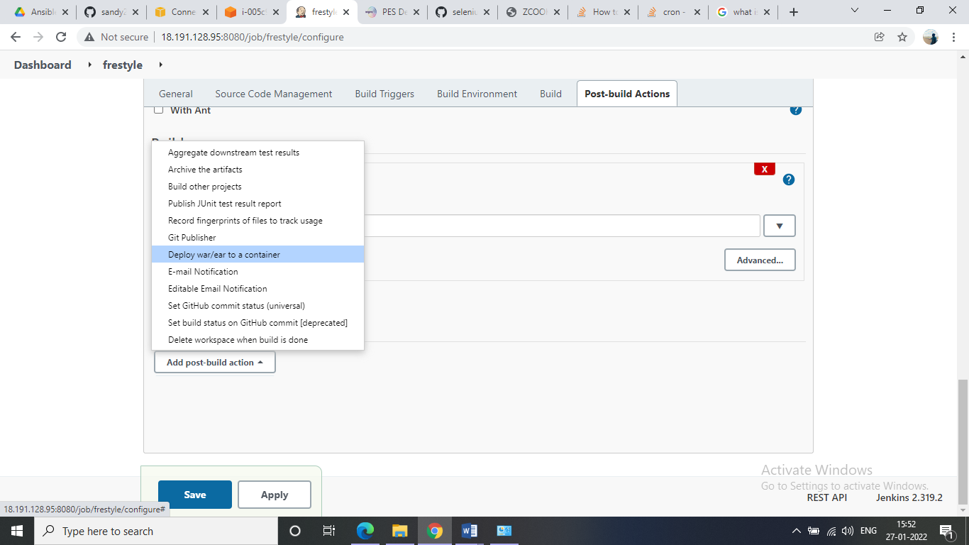

Follow the same things as shown in below path for war/ear give the same

**/*.war

Context path: You can give whatever you required

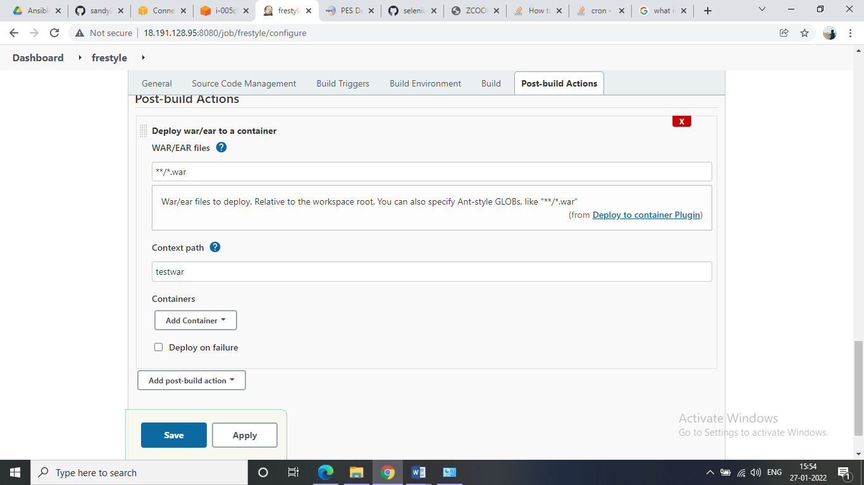

Once you have given select the container where you’re trying deploying it like tomcat/jboss etc as shown below

Select the container and give the path of it or IP address of that container

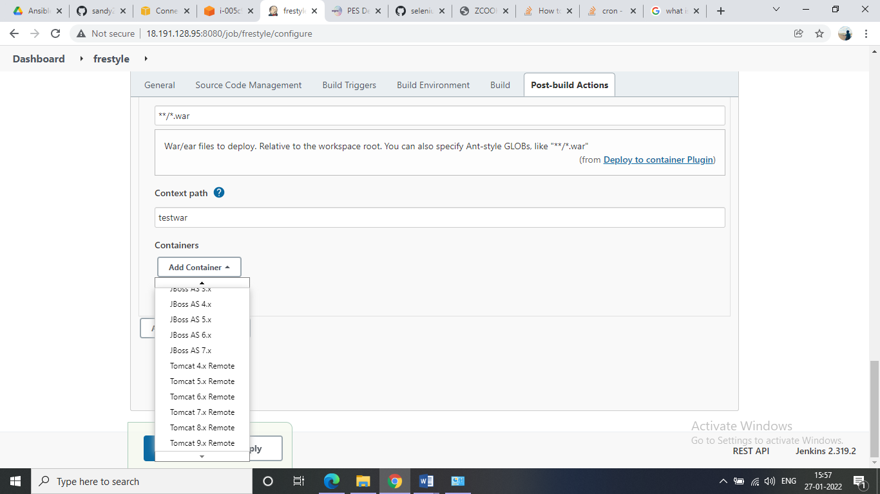

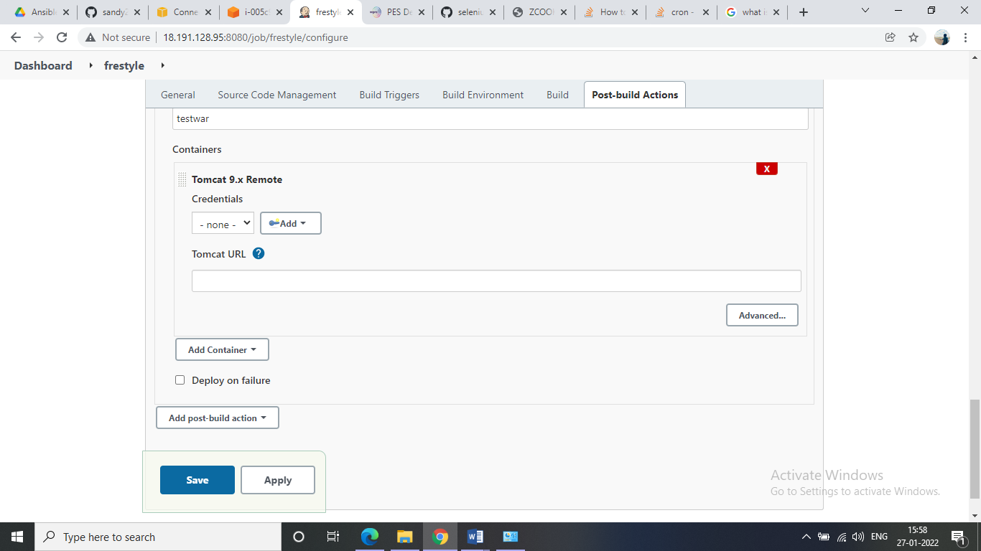

Then click and apply save

Now go to dashboard of job and run it